**Strategic and Twitch**

This game is designed based on how players use their mobile devices to search for images on the internet to find requested pictures from their opponents. The searcher will have to explain its meaning with the question request within a given time. The final winner will be the one who does not lose more than 3 turns of the answer. Rewards include gifts such as candy, or cakes.

Mechanism:

The game is designed from 2-4 players and divided into 2 teams (4 people), 3 teams (3 people). Players do a web search for images and then explain what they mean to the question. Each team that completes their answer will continue to the next team until they cannot find an answer. The team that loses the turn 3 times will be the loser and the other team will win.

Rule:

Each player will write on 2 paper cards about an object around them and they must have the composition details. Then mix them and the team randomly picks one card and leaves it to face up.

After the card is turned on and both teams will use their phones to search for possible photos or materials to create the item listed on the card. Within 2 minutes each team will save a photo or screenshot to start giving evidence and presenting it to the opposing team. A potential player who has acquired more materials or tools to create them will be the dominant player and will not lose their turn if such interpretation is not agreed upon by both teams.

At the end of 2 minutes, teams will be given 10 seconds for each answer to competing for the reasonable answers.

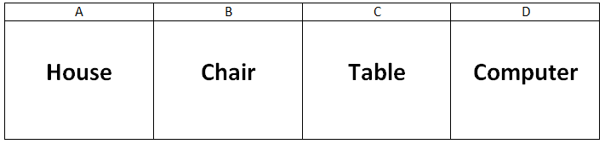

For example, here are 4 cards A, B, C, D. Inside are the names of objects that when each team plays their selection, teams have 2 minutes to search for materials or tools to create them as:

Card A - House: talks about the items that make up the house such as wood, brick, and cement, what do they do to form a house, teams will find pictures and explain them to all players.

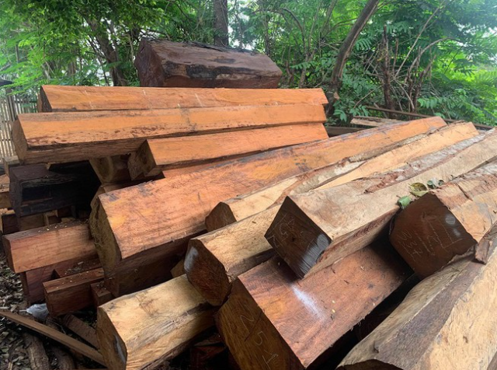

The example here is the wood that will be used for floors or doors.

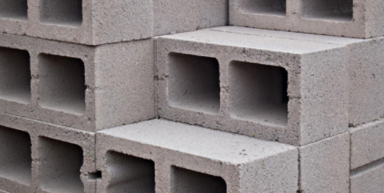

Bricks are used to build walls.

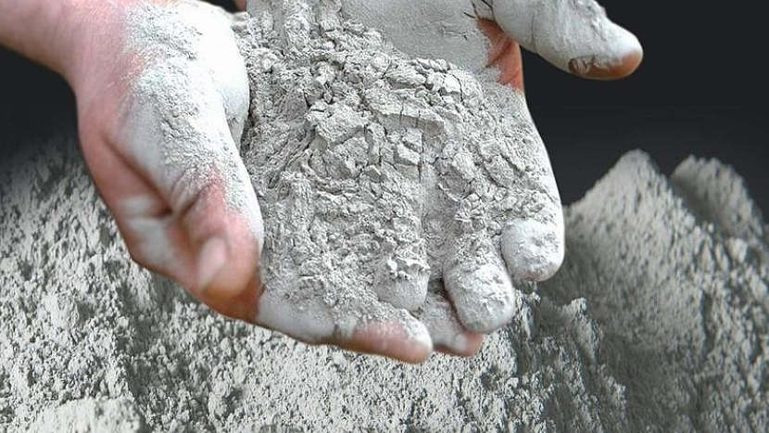

The raw materials are mixed with sand to form a concrete mixture.

The above are examples that both teams have to give and explain to everyone to understand to create a story about a created topic.

During the game testing, everything went smoothly. But there were some problems when the interpretation of some examples was not approved by some of the participants. Therefore, there are still some difficulties in deciding whether or not the answer is reasonable or not. However, conflict while playing is unavoidable, making opinions or arguing about personal opinions makes the game more stressful. Therefore, there should be a clearer mechanism and rules for players to understand and make use of the time to play.

As a game developer, I have worked on making the rules and logical criteria for the players. However, there are still many shortcomings in the tutorial and giving instructions so that players can easily experiment.

Test players include: Connor Winspur, Hou Yuen Yap

**References:**

NT, C. (2020) *Xi măng nở có khả năng sửa chữa cấu trúc bê tông - Xi măng Việt Nam*. Available from: https://ximang.vn/nguyen-nhien-lieu/xi-mang-no-co-kha-nang-sua-chua-cau-truc-be-tong-12559.htm [Accessed 27 November 2020].

Shac (2020) *Chọn loại gạch xây nhà nào là tốt nhất? Tham khảo ngay khi xây nhà 2021*. Available from: https://shac.vn/chon-loai-gach-xay-nha-nao-la-tot-nhat [Accessed 27 November 2020].

Plo (2020) *Phát hiện hàng trăm khúc gỗ trong một xưởng ở Gia Lai*. Available from: https://plo.vn/an-ninh-trat-tu/phat-hien-hang-tram-khuc-go-trong-mot-xuong-o-gia-lai-921250.html [Accessed 27 November 2020].